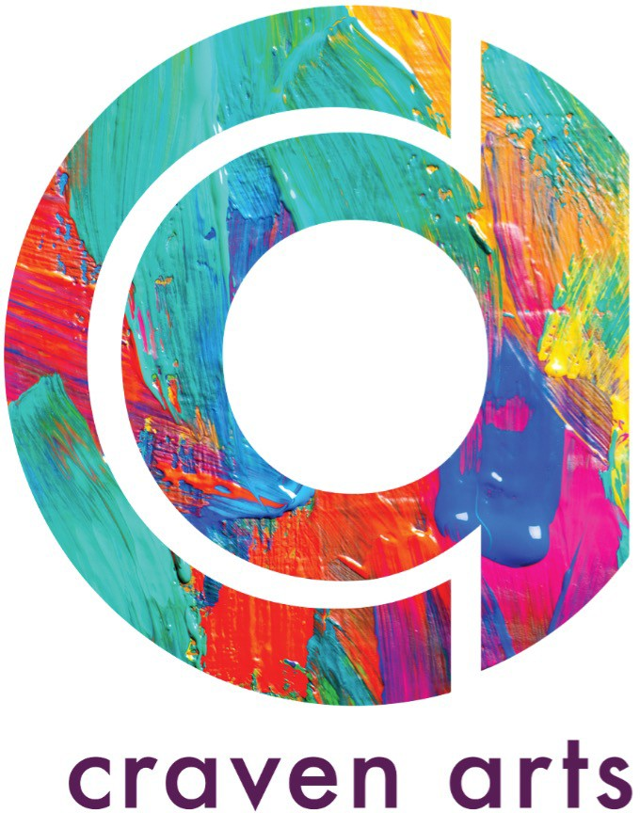

Membership Application Form

I wish to apply for membership of CRAVEN ARTS Starting on the date: year:

Name of the applicant:
Year of Birth: Profession:
Artist Discipline:
Address: Web Site/online presence : Phone number :
Email address for correspondence (please print clearly):

All your information is protected by data protection laws. Please see more info in the end of the contract.
Please read carefully before completing your application Information can also be found on www.cravenarts.com/membership
Individuals can apply for Full Membership or Supporting Membership:

- Full membership

Open to all practicing professional visual artists*, [18yrs+] living in Craven and Skipton (within 20 miles radius of Skipton)
Please submit together with your application form:
  - a copy of your CV (or your website in case your cv is online)
  - 4 examples of artwork (good quality images of 300dpi and max 2mb) and artist’s statement (max 60 words)
  - ARTIST PLEDGE NETWORK –pledge to donate 2 hours of your time (see ‘duties and obligations’)

- Supporting Membership
Open to any person with an interest in supporting the work of Craven Arts

Please mark accordingly

- Full Membership £ 20
- Supporting Member £ 20
- Other Donation amount £
- I would like Gift Aid to be claimed on my membership fee and I have completed the Gift Aid declaration form attached.

- I have read & agree to the Craven Arts code of conduct and Privacy Policy
- As a member I pledge to give 2h/year of my time to a local community group, organisation or charity in the form of a workshop, talk or any creative help/activity.
(Explanation: In order for Craven Arts to be a charity each member donates 2h of their time to the community for free. The way this is done is open to interpretation. Please speak with a trustee for further clarification.)

Signature of Applicant Date (dd/mm/yyyy)

CRAVEN ARTS Full member benefits:

-Only a *Local Practicing Visual Artist* is able to be a member of the Charity
-Members have a right to volunteer to be on the Trustee Board
-Members have a right to vote for trustees for the Trustee Board
-Members have a right to vote for issues assigned by the Trustee Board
-Members are entitled to rent the artist studios and workshop/meeting room(s)
-Members are invited to all of the Charity events and get discounts

Full Member duties and obligations:
-To act in good faith, and in your charity’s interests
-Members have an obligation to donate 2 hours of time delivering an artistic workshop/talk/event a year to the
Arts Pledge Network for a Local Charity, School or Organisation or at the annual Craven Arts weekend/Exhibition
-Pay your membership fees in time
-Attend annual meetings
-Exercise Members voting right

*Practicing Visual Artist:
- In possession of self-made artwork amounting to an exhibition or equivalent body of work
- Part of income generated from making own visual art or sold a piece of self-made art.

-Visual arts- all arts that can be seen and touched.
Full list of considered Art practices may be obtained through our secretary- please email: info@cravenarts.com

CRAVEN ARTS Supporting Member benefits:

-Supporting Member can be anyone willing to support the Charity
With a yearly membership fee and possible donation(s) and volunteering
-Supporting Members are invited to Craven Arts events and get discounts
-New Supporting Members are automatically accepted at any date

Supporting Member duties and obligations:
-To act in good faith, and in your charity’s interests
-Pay your membership fees in time

Procedure to be accepted as CRAVEN ARTS member:
Complete application form legibly, sign, and send it, with attachments to the membership secretary, (address details below). Keep a copy for your records.
After your application has been received, the Craven Arts Trustees will assess your application.
You will be informed of the outcome as soon as possible.
Your email address will be forwarded to the Treasurer who will send you an invoice for the membership fee. Please do not transfer the money or send a cheque until you are notified of the status of your application.

CRAVEN ARTS code of conduct (see website www.cravenarts.co.uk):

CRAVEN ARTS requires that members agree to abide by a “Code of Conduct”. The Code of Conduct stipulates:

  - CRAVEN ARTS is an independent body and acts to provide support for the Craven community of visual artists.
  - The name and/or membership of CRAVEN ARTS must not be used to promote personal and/or organisational views and philosophies, unless directly ordered/permitted to do so by the CRAVEN ARTS Trustee board.
  - The name and/or membership of CRAVEN ARTS must not be used for financial and/or commercial gain
or unless directly requested/permitted to do so by Trustee use the CRAVEN ARTS logo without permission
board.
  - Members only act in the best interest of the CIO and never act in any way likely to jeopardise the integrity of the CIO or bring it into disrepute.

Failure to comply with the Code of Conduct may result in termination of membership of CRAVEN ARTS and the forfeiture of any membership fees previously paid.

Please sign, scan and then post or e-mail the completed form and attachments to:

Craven Arts Studio/ Membership
7a Otley Street, Skipton, North Yorkshire, BD23 1DY info@cravenarts.co.uk

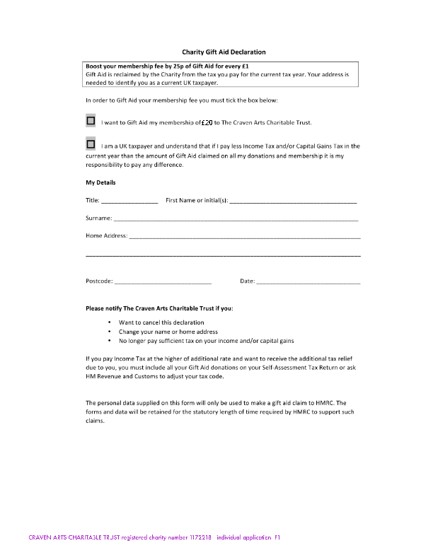
THE CRAVEN ARTS CHARITABLE TRUST - PRIVACY POLICY

Here, you can find out how we safeguard your information and how we use it to improve our services for the benefit of all our Members and online users.

From time to time, we’ll require some personal details from our Members, Supporting Members and website users.

The data we collect could just be a name and an email address, but depending on your level of engagement with Craven Arts, it could be more than that.

The personal information you’ve shared with us, help us to better understand our members as a group and as individuals. This in turn helps us to provide a range of connections and services that meet your needs.

How we protect your data

Your privacy is extremely important to us. We’re committed to protecting any personal information you’ve given us, and we comply with all relevant data protection laws.

This means that:

- We take full responsibility for the information we hold about you
- We will protect your privacy at all times
- We will never sell your personal information
Whether you’ve supplied your personal details online, by phone or text, by email or in a letter, we will never use them without a lawful reason to do so. We’ll use them for the purposes for which they were initially requested and as fully explained in this Privacy Notice.
These explain how your personal data is being managed and safeguarded by us, including:
- what information we collect about you
- how we collect and use this information
- how we safeguard the information you’ve provided
- your rights in relation to the information we hold about you
- how to report abuse
This Privacy Notice is designed to help you understand how we collect and use your personal information.
This Privacy Notice applies to all the pages on our sites and any features of them and any other areas which require registration on our sites. However, it won’t apply to any third-party sites which are linked to our sites. We recommend that you read the privacy notice of any such sites that you visit as we are not responsible for them. The Website provider we use, Wix, has cookies enabled for the site to make sure your computer (or other device) is recognized when you visit there again.
You can find more about cookies on their website {www.support.wix.com}.
When we refer to our website or sites mean any of our websites or applications (Wix, Gmail, Survey Monkey, Facebook, Twitter, Drop Box) we from which you have accessed this Privacy Notice.

At Craven Arts, we know that you care how your personal information is used and we appreciate that you trust us to do that carefully and sensibly.

****************************************************************************************
What information does Craven Arts collect about me?
Personal information that we collect may include your name, contact details (phone numbers, email address and addresses), web- sites, your year of birth, job, artistic discipline, as well as any other personal information relating to you that you supply to us (i.e. CV).

Some of our sites may also collect other information that you supply to us, such as information relating to your education, skills or job experience, where relevant in the context of the site or the services provided through the site. Except where stated otherwise on the site at the time such personal information is submitted, it is only processed for the purposes for which you have submitted it to us.

How does Craven Arts collect my personal information?
Personal information you choose to disclose. You may, for example, provide us with your information when you post something on our site, when you register as a member on our site or when you contact us (online or offline).

We will inform you prior to collecting your personal information if it is requested on a voluntary basis and the consequences of not providing voluntary personal information.

What will Craven Arts do with my personal information?
Craven Arts will use your personal information for a variety of purposes, which are in our legitimate interests ("Charity Purposes"), and/or in order to enter into or perform a contract with you ("Contractual"), and/or with your consent ("Consent"), and/or compli- ance with our legal obligations ("Legal Reasons"). For example, we may use your personal information:
- to provide you with the relevant services through our applicable site, for Contractual Reasons
- to inform you about and provide more information on services offered by us and our associated companies
- to invite you to participate in surveys, discussions, exhibitions, job opportunities and prize draws and ask for your views on our services via online surveys and discussion forums, for our Charity Purposes and/or with your Consent
  - to improve the services offered to you
  - for marketing for our Business Purposes and/or with your Consent
  - for statistical or analytical purposes for our Charity Purposes
  - to detect, prevent or investigate security breaches or fraud for our Charity Purposes and/or Legal Reasons
  - to otherwise to better meet the needs and preferences of our Members for our Charity Purposes

We will not allow unrelated third parties to use your personal information for marketing without your consent. Where we rely on your consent, you have the right to withdraw it at any time.

We also use personal information to identify types of user, audit how our sites are used, and to help with the strategic development of our sites. When doing so, we remove any direct identifiers.

Participation in surveys and discussion forums is entirely voluntary. You may unsubscribe from being contacted for these purposes at any time. Survey information will be used for market research with the aim of improving our services.

We will show your username on any content you submit or post on our sites (including discussions, bulletin boards and forums). We may from time to time supply data to third parties in an anonymised form for uses in connection with our site and the purposes of advancement of Craven Arts.

How long will Craven Arts keep my personal information?
We will keep your personal information only for as long as necessary to fulﬁl the purposes for which we are processing your personal information unless the law permits or requires longer. For example, we might need to keep your personal data for quality assurance of the service we have provided (1 year), or we might need to keep it to defend future legal claims (6 years). We usually would delete all your information instantly if you cancel your membership or supporting membership.

Email opt-out
We will not send you emails if you have opted out of receiving them. Any emails we send you will include an unsubscribe option at the end of the email. Some Craven Arts sites also provide other contact details you may use if you want to contact us by email or post in order to unsubscribe.
You can unsubscribe from any communications at anytime or report abuse by sending us an email to: info@cravenarts.co.uk

How does Craven Arts keep my personal information safe?
We seek to protect the safety of all your personal information by implementing appropriate technical and organisational measures. All your personal information is under passwords and handled only by task assigned people.
Any personal information that you voluntarily post on a public area of our site, such as a bulletin board or discussion forum, or an interactive area requiring registration and/or subscription, may be collected and used by others. Please be careful what personal information you disclose in this way. You understand that we cannot control the actions of other users.
You can ask for a summary of the information we have of you from: info@cravenarts.co.uk

